# Homework 3 - Policy Based Management

Ryan Foster

CIS 483-01

* Screenshots should show the full contents of the conditions and policy you have created, not just the names.
* **Task 1.** Show in a screenshot the condition(s) you have created.
* **The first picture shows the actual condition that was used to ensure the naming convention follows the ‘tb_%’.** I had to create the additional “OR” just to show the red ‘Xs” that appear. If I only do the first statement then it only shows

* **Task 2.** Show in a screenshot the policy you have created.

* **Task 3.** Show in a screenshot the test results using the four tables that are provided above.
* **This is what I was referring to in Task1 answer.** This first picture is reflective of the first condition with just the “Like” statement. As you can see, it doesn’t show the red “X’s” like in the example but only shows the two green checks for “tb_Department3” and “tb_Department4”

This is what I was referring to in TASK 1 with having to make the “OR” statement just o show that it is indeed checking and showing results for Department 1 and Department 2 not having the “tb_” before them. The results don’t show so I only have this screenshotted to get them to show.

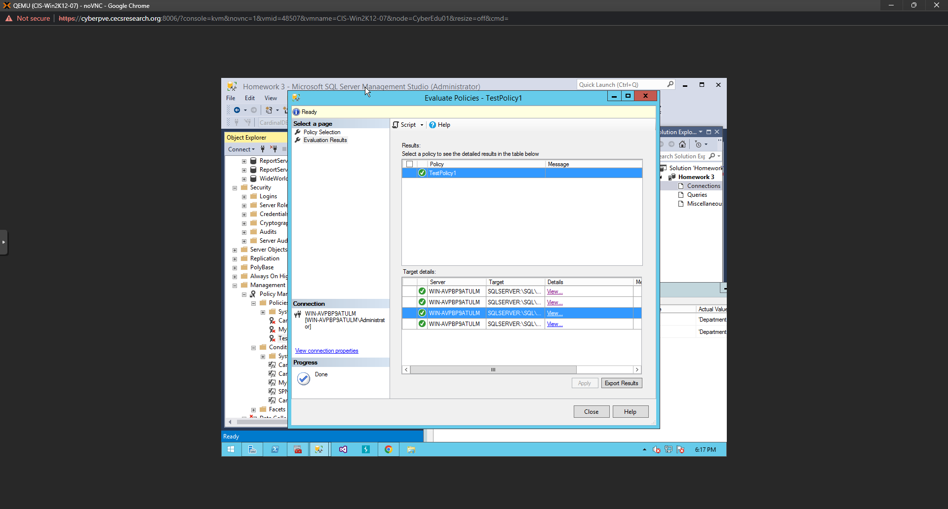

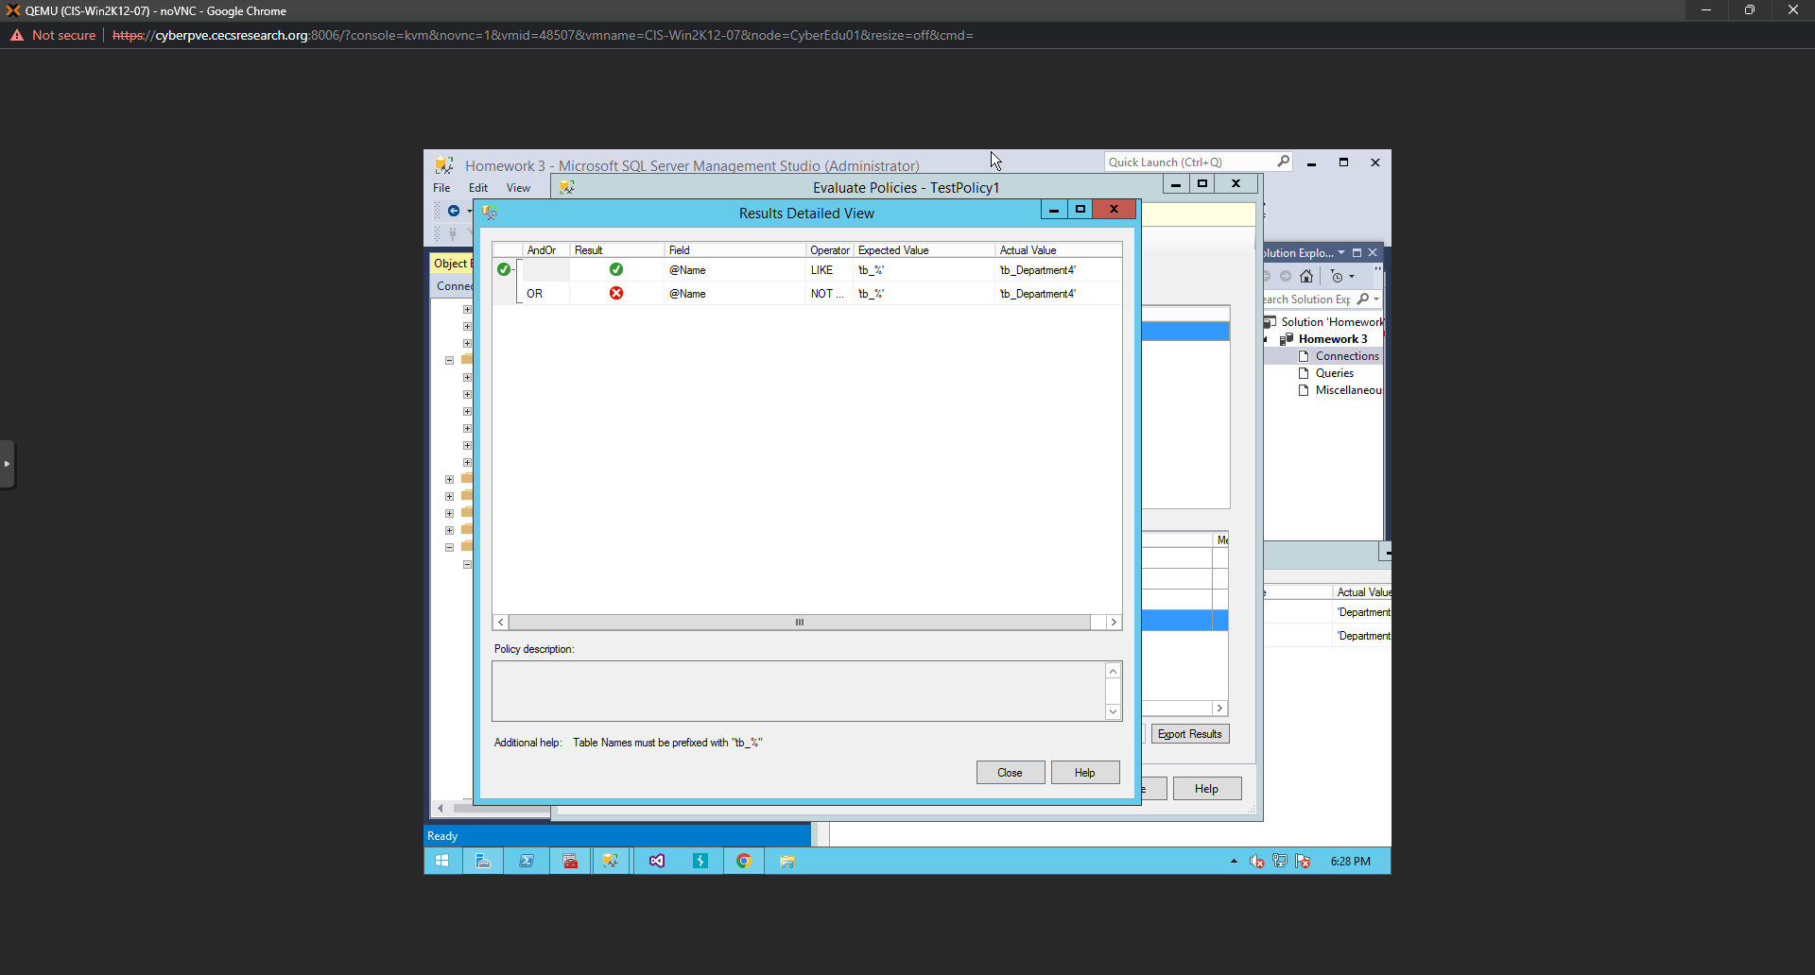

* **Task 4.** Explain the results at Task 3.
* **The results show that the first condition targets the database “CardinalDB”**
* **The second condition sets the facet to “Tables” for this exercise. The tables that are created are checked to see if they meet the requirement of beginning with “tb_”. The policy then uses the two conditions in tandem to run the two conditions and make the check.**